**Florida Atlantic University – Presentation Classrooms – Concept of Operation Description**

**Spring/Summer 2012**

**Classroom AV system capabilities:**

* Ability to use built-in-room devices for class presentation use, including a PC, Document Camera and Blu-Ray Player
* Ability to use instructor-provided devices for class presentation use, including Laptops, mobile devices and analog video devices (typically VCRs)
* Instructors use a 20-button keypad for all system controls (inc. doc cam and Blu-Ray player) - No remote controls needed anymore
* Provide room audio via stereo wall-mounted speakers in front of room
* Provide digital connectivity for PC, Blu-Ray deck and user-provided Laptops to ensure HDCP compliance with video content and prepare for future unavailability of analog VGA signals
* Provide presentation annotation capability via SMART Podium SP 518 interactive pen display
* Provide simplified system signal flow for troubleshooting and tech support purposes – one rack device for video switching, control, audio mixing and amplification
* Provide RoomView Fusion integration for remote management and usage data collection

**User Interface: Crestron MP-B20 20-Button Keypad**

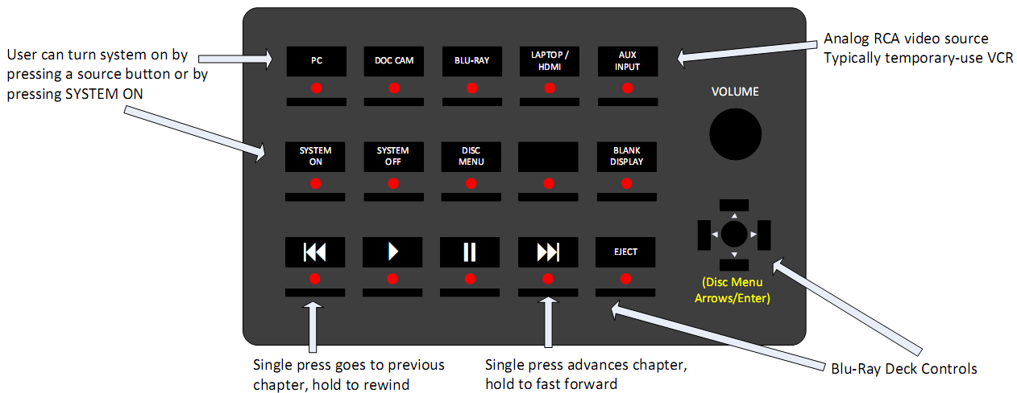

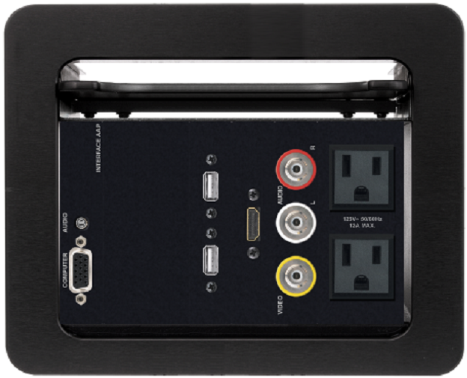**Plug-In Interface for User-Provided Devices: Extron Cable Cubby 600**

- Provides space in the future to replace existing VGA/audio plugin plate with a retractor

- Connections provided (from left-to-right):

- 1 VGA with 3.5mm audio for laptops

- 2 USB inputs – flash drive, presentation clickers, etc.

- 1 HDMI input for laptops, mobile devices, etc.

- 1 Composite video/stereo RCA audio for VCRs

- 2 AC power sockets

- The VGA and HDMI inputs are tied to the “LAPTOP/HDMI” keypad button functionality; will auto-select between VGA and HDMI when this button is pressed.

***Classroom AV System Operational Behavior Details - Comments are Included within Brackets []***

* User may play audio from PC when system is off
* User will see the PC video signal on the SMART Podium display when system is off
* User may turn system on by momentarily pressing any of the following buttons: System On, PC, Blu-Ray, Laptop, Doc Cam or Aux Input [any source button will activate system; all buttons are momentary press (not press & hold) ]
* When user turns system on:
  + SYSTEM OFF LED on MB-B20 keypad goes off
  + SYSTEM ON LED on MB-B20 keypad blinks during system startup time [provides feedback to user that system is turning on]
  + Set up sources, projector, etc. in room
  + Set volume level to 50%, as shown on MB-20 keypad bar graph
  + Turn on Blu-Ray player at system startup time [this way users don’t have to wait for the Blu-Ray deck to power up when it is selected later]
  + Ignore any other keypad button presses while system starts up [prevent system from going into an unknown/inconsistent state during startup]
* At end of system startup time:
  + MB-B20 keypad SYSTEM ON LED stops blinking & stays on
  + MB-B20 keypad active source (PC, Laptop, etc.) LED lights up
  + MB-B20 keypad backlight turns on [provides feedback to user that system is completely on and ready for use]
* If system is already on & user presses a source button (PC, Laptop, etc.):
  + Turns off the previous source’s keypad LED
  + System sets up the new source, performs video/audio routing, lights the LED under that source button
* Specific Doc Cam behavior – when user presses the DOC CAM button on the MB-B20 keypad:
  + Sets up projector to show the doc cam VGA/DVI output
  + If PC is setup to use e-control software & control system is on campus network:
    - Show the PC on the Sympodium panel
    - Starts the Epson viewer software on the PC [ensures instructor always sees the doc cam preview software w/o having to start it on their own]
  + If PC is NOT setup to use e-control software or control system is NOT on campus network:
    - Show the doc cam VGA/DVI output on the Sympodium panel [instructor will not be able to use Epson software capture capabilities but will still see a doc cam preview on Sympodium]
  + Above behaviors are automatic – program will adapt to either condition when that condition is met
  + Note: To provide the control system FAU network access, need to install in the rack an intermediate router/NAT/private dhcp server device
* User turns off system by momentarily pressing System Off button:
  + Turns off equipment: Blu-Ray deck, projector, doc cam
  + Routes PC audio back to room speakers [Can play audio from PC when system is off]
  + Routes PC video back to Sympodium display [Can use PC when system is off]
* Room-specific settings (such as audio input gains, mixer levels) shall be configured within the DMPS-300 during installation and not by the control program [Allows same program to be used in multiple venues; future room audio adjustments can be made w/o program changes]
* Shall determine appropriate audio loudness scaling such that 2 complete turns of the MP-B20 knob goes from minimum audio level to maximum audio level [This process will set the Minimum Volume, Maximum Volume for the specific room]
* At this time there shall be no MUTE AUDIO capability in the system [no MP-B20 keypad button is assigned for this]
* At this time there shall be no HELP button capability in the system [Need to have a way to let users know that a help request is being responded to – in room feedback – before we provide this capability]
* **RoomView requirements are specified as follows but cannot be tested until the RoomView Fusion environment is ready:**
  + Use RoomView -> processor time sync capability to keep time correct on room control systems
  + Provide status reporting for both projectors in rooms with dual projectors
  + Provide capability to do a program reset or hardware reboot from RoomView
  + Use the RoomView symbol error alerts/error message capability to send RoomView alerts when projector is disconnected or when projector status is anything other than ok
  + Provide projector lamp % used value to RoomView (total possible lamp hours will change depending on model of projector in room)
  + Report current action to RoomView: Off, Show PC, Show Laptop/HDMI, Show Doc Cam, Show Aux Input, Show BluRay
  + Report device usage data from above actions: Time spent in each activity with Crestron device usage data module
  + Once Help button capability is implemented, messages will be sent from RoomView, not directly from control systems